Domain Background

As the covid-Sars-2 ravages throughout the world, scientists are racing to understand the characteristics of this new virus. The pandemic is gradually being controlled by the high-income countries and now hitting the small to middle income nations, which according to the world bank will through about 7 million people to extreme poverty.

Since tomography is not widely available, x-rays help doctors understand the extent of the damage of the lungs from their patients. An AI platform that suggests the doctor the diagnostic of their patient’s lungs could accelerate and improve the speed of attention at hospitals.

In academia, deep learning is starting to be used more widely as a diagnostic aid (cite source). The task of detecting common patterns is lengthy and costly for healthcare workers, both in western medicine as well as Chinese complementary medicine. In this last one, signs in the body –such as tongue or heart rate-- are well documented for detecting deficiencies and syndromes in a person. Therefore, I believe that in the future, computer vision and signal processing AI will be a key player in medicine.

Problem Statement

The problem is a classification for 4 classes. This model classifies between normal, pneumonia caused by another virus, covid-19, and pneumonia caused by bacteria.

Datasets and inputs

The dataset consists in 7 types of x-rays. Stress-Smoking, streptococcus and SARS will be discarded because there is not enough data. We can also see that Pneumonia bacteria has 2.772 images, so the model is unbalanced with respect to the other classes.

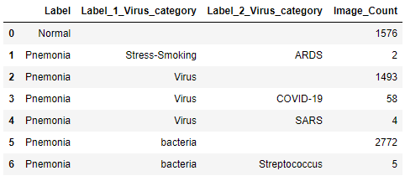

Benchmark model

The benchmark model to compare to is the flower classification from the transfer-learning class from Udacity’s deep learning with pytorch course. This is a VGG model, a CNN whose last layer is trained to classify flowers. <https://cs231n.github.io/transfer-learning/>

The accuracy for each of the seven types of flowers is ……..

Evaluation metrics

The percentage of precision for each class will be tracked. That is, how many of the pictures inside a class were classified correctly.

Project design

Augmentation

First, since the covid x-rays are just 58 pictures, the images will be augmented to be approximately equal in number to the other classes. Stress-Smoking, streptococcus and SARS are discarded because there is not enough data. In the augmentation process, the pictures are cropped to the size appropriate for the algorithm (224x224). They are not mirror-ed (flipped) because chest-rays are always taken from the back. However, the pictures are transformed with other methods to augmentate their number.

The strategy is to use AWS SageMaker to create a CNN model that can use GPUs during training and can be deployed if needed. A third party application (Cyberduck is used to upload the files (>1Gb) without interruption to the S3 file storage system.

Then, the code trains the last layers of the pretrained CNN model. It is key to use an already trained model because they are trained even for weeks at a time in multiples GPUs. Therefore, the project will use a VGG16 model as a starting point. The code also takes advantage of the AWS SageMaker SDK for python to instantiate de models and deploying them.